

**DESIGN AND CONTROL OF TORSO BALANCING MECHANISM FOR BIPEDAL WALKING ROBOT**

An Internship Report Submitted to

**DR. VISHWANATH KARAD**

**MIT WORLD PEACE UNIVERSITY**

Submitted by,

**Muskan Hiteshkumar Patel (1032200264)**

Under the supervision of

**Prof. Vivek Sangwan**

and

**Ass. Prof. Dr. Ashish H. Pawar**

**School of Mechanical Engineering**

**MIT World Peace University, Pune**

**Kothrud, Pune-411038**

**(Period from 15th January, 2024 to 14th May, 2024)**

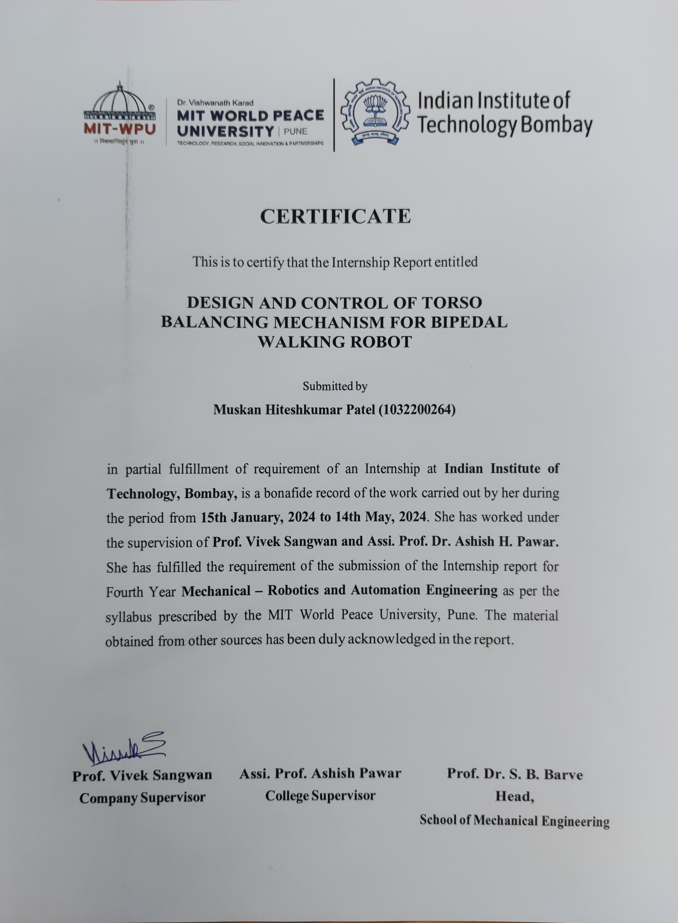



**Vision and Mission**

|  |
| --- |
| **Vision of Faculty of Engineering and Technology** |
| To be a globally recognized leader in Engineering Education having a constructive impact on society. |
| **Mission of Faculty of Engineering and Technology** |
| 1. To achieve academic excellence through Continuously Updated Education (CUEd). 2. To create environment of technology research and social innovation by establishing trans-disciplinary centers of excellence. 3. To establish strong partnerships with reputed industry and research organizations. 4. To promote ethical and universal value based professional education. |

|  |
| --- |
| **Vision of School of Mechanical Engineering** |
| To be a center of academic excellence in Mechanical Engineering for sustainable development. |
| **Mission of School of Mechanical Engineering** |
| 1. To impart comprehensive knowledge in mechanical engineering and foster skills to enhance economic development of the nation. 2. To facilitate trans-disciplinary research leading to innovative technologies. 3. To collaborate with academia, industry and research organization globally. 4. To nurture students for lifelong learning and ethical professional career. |

**ACKNOWLEDGEMENT**

It gives me great pleasure to work as a research intern on project named “**DESIGN AND CONTROL OF TORSO BALANCING MECHANISM FOR BIPEDAL WALKING ROBOT**” at IIT Bombay. In presenting this internship project work, a number of hands helped me directly and indirectly. Therefore, it becomes my duty to express my gratitude towards them.

I am grateful to Prof. Dr. Vivek Sangwan for giving me the opportunity to work as an intern at IIT Bombay and giving proper guidance throughout the internship duration. His timely suggestions made it possible to complete this internship for me. All efforts might have gone in vain without his valuable guidance. I would like to express my heart-felt gratitude towards Prof. Dr. Ganesh Kakandikar, in School of Mechanical Engineering, to recommend me for this project under the guidance of Prof. Dr. Vivek Sangwan. I would also like to thank Asst. Prof. Dr. Ashish Pawar for supervising and counselling me on regular basis during the internship.

I will fail in my duty if I won't acknowledge a great sense of gratitude to the head of School of Mechanical Engineering, Prof. Dr. Shivprakash B. Barve and the entire staff members in the School of Mechanical Engineering for their cooperation.

**Muskan Hiteshkumar Patel**

**BTech Mechanical Engg.**

**PRN No: 1032200264**

**ABSTRACT**

Bipedal walking robots represent a significant advancement in robotics, mimicking human-like locomotion and balancing capabilities. In this study, we focus on the design and control of a torso balancing mechanism for such robots. The proposed mechanism employs a plank structure with two BLDC (Brushless Direct Current) motors mounted on either side, tasked with dynamically stabilizing the robot during locomotion. This research aims to derive the dynamical equations governing the motion of the plank, implement a PID (Proportional-Integral-Derivative) controller to regulate the motor speeds, and integrate feedback from an MPU6050 inertial measurement unit for real-time stability control. The dynamics of the plank are derived using principles of classical mechanics and control theory. The equations of motion consider the inertial properties of the plank, the torques generated by the BLDC motors, and the external disturbances encountered during operation. By modeling the system dynamics, we establish a mathematical framework that governs the interaction between the plank's motion and the control inputs provided by the motors. To achieve stable bipedal locomotion, a PID controller is implemented to regulate the motor speeds in response to deviations from the desired orientation. The PID controller utilizes feedback from the MPU6050 IMU, which provides accurate measurements of the plank's orientation and angular velocities. By continuously adjusting the motor speeds based on the error between the desired and measured orientations, the PID controller effectively counteracts disturbances and maintains the robot's balance. The design of the torso balancing mechanism involves careful consideration of mechanical, electrical, and control aspects. The selection of BLDC motors with appropriate torque and speed characteristics is crucial for achieving the desired balancing performance. Additionally, the mechanical design of the plank must ensure structural integrity while minimizing weight and inertia to facilitate agile locomotion. Experimental validation of the proposed mechanism is conducted using a prototype bipedal walking robot platform. Real-world testing scenarios are employed to assess the system's performance under various conditions, including uneven terrain and external perturbations. The effectiveness of the PID controller in stabilizing the robot's torso is evaluated through quantitative metrics such as orientation error and stability margins. The outcomes of this research contribute to the advancement of bipedal walking robotics by providing a robust solution for torso balancing mechanisms. The derived dynamical equations, coupled with the PID control approach, offer insights into the complex interactions between mechanical design and control algorithms in achieving stable locomotion. The experimental results demonstrate the feasibility and effectiveness of the proposed mechanism in real-world scenarios, paving the way for further developments in bipedal robot locomotion and human-robot interaction.

**CONTENTS**

|  |  |  |  |
| --- | --- | --- | --- |
| **Sr. No.** |  | **Name of Sections** | **Page No.** |
|  |  | Certificate |  |
|  |  | Vision and Mission |  |
|  |  | Acknowledgement |  |
|  |  | Abstract |  |
| 1. |  | DETAILS OF THE ORGANIZATION |  |
| 2. |  | INTRODUCTION |  |
| 1.1 | Background |
| 1.2 | Problem Statement |
| 1.3 | Objectives |
| 1.4 | Scope |
| 3. |  | REVIEW OF LITERATURE |  |
| 4. |  | METHODOLOGY |  |
| 5. |  | RESULTS/ANALYSIS |  |
| 6. |  | CONCLUSION |  |
| 7. |  | FUTURE SCOPE |  |
|  |  | APPENDIX A (Acronyms and Abbreviations) |  |
|  |  | APPENDIX B (Glossary) |  |
|  |  | Bibliography |  |

#### DETAILS OF THE ORGANIZATION

Established in 1958, the Indian Institute of Technology Bombay (IIT Bombay) is one of the premier engineering institutes in India. Located in Powai, Mumbai, it is renowned for its excellence in education, research, and innovation. Offering undergraduate, postgraduate, and doctoral programs across various disciplines of engineering, science, design, and management, IIT Bombay consistently ranks among the top engineering institutes globally. It boasts state-of-the-art facilities, cutting-edge research centers, and a vibrant campus life. With a strong emphasis on interdisciplinary collaboration and industry partnerships, IIT Bombay fosters a conducive environment for students and faculty to pursue academic excellence and contribute to societal development. Its alumni network spans the globe, with graduates making significant contributions to academia, industry, and entrepreneurship. IIT Bombay continues to uphold its legacy of producing leaders and innovators who drive technological advancements and social change.

Mechanical Engineering at the Indian Institute of Technology Bombay (IIT Bombay) is a flagship program known for its academic excellence, research opportunities, and industry connections. The department offers undergraduate, postgraduate, and doctoral programs in Mechanical Engineering, covering a wide range of subjects such as thermodynamics, fluid mechanics, manufacturing processes, robotics, and automotive engineering. With world-class faculty members, state-of-the-art laboratories, and cutting-edge research facilities, students receive comprehensive training in theoretical concepts and practical skills. The curriculum emphasizes hands-on learning through projects, internships, and industry collaborations, preparing graduates for successful careers in diverse sectors including aerospace, automotive, energy, manufacturing, and robotics. Alumni of the Mechanical Engineering program at IIT Bombay are renowned for their contributions to academia, industry, and research, making significant advancements in technology and addressing complex engineering challenges on a global scale.

#### INTRODUCTION

#### Background

Bipedal walking robots have long been a subject of fascination and research in the field of robotics, primarily due to their resemblance to human locomotion and the challenges they pose in terms of control and stability. Inspired by nature, these robots aim to replicate the complex motion and balance exhibited by humans while walking. Achieving stable bipedal locomotion requires not only advanced mechanical design but also sophisticated control algorithms to maintain balance and stability in dynamic environments. The concept of torso balancing mechanisms for bipedal robots stems from the fundamental principle of maintaining the center of mass within the support polygon to prevent toppling over. Traditionally, bipedal robots have employed various strategies for balance, including passive dynamic walking, active joint control, and external support systems. However, the development of torso balancing mechanisms presents a promising approach to enhance the stability and agility of bipedal robots, particularly in scenarios involving uneven terrain or external disturbances.

#### Problem Statement

Despite significant advancements in robotics, achieving stable bipedal locomotion remains a challenging problem due to the inherent complexity of dynamic balance control. One of the key challenges lies in designing effective torso balancing mechanisms that can dynamically adjust the robot's posture in real-time to counteract disturbances and maintain stability during locomotion. The integration of such mechanisms requires a comprehensive understanding of the mechanical, electrical, and control aspects involved, as well as the development of robust algorithms for feedback control. The specific problem addressed in this study revolves around the design and control of a torso balancing mechanism for a bipedal walking robot. The mechanism consists of a plank structure with BLDC motors mounted on either side, tasked with generating variable torques to stabilize the robot's torso. The challenge lies in deriving the dynamical equations governing the motion of the plank, designing an effective PID controller to regulate the motor speeds based on feedback from an IMU, and validating the performance of the mechanism through real-world experiments.

#### Objectives

The primary objective of this research is to design and implement a torso balancing mechanism for a bipedal walking robot capable of maintaining stability during locomotion. To achieve this overarching goal, the following specific objectives are outlined:

* Derive the dynamical equations governing the motion of the plank structure with mounted BLDC motors.
* Design and implement a PID controller to regulate the motor speeds based on feedback from an MPU6050 IMU.
* Integrate the torso balancing mechanism into a prototype bipedal walking robot platform.
* Conduct experimental validation to assess the performance and effectiveness of the mechanism under various operating conditions.

By addressing these objectives, we aim to contribute to the advancement of bipedal walking robotics by providing a robust solution for torso balancing mechanisms that can enhance stability and agility in dynamic environments.

#### Scope

This study focuses specifically on the design and control of a torso balancing mechanism for a bipedal walking robot, with emphasis on the mechanical design, dynamical modeling, control algorithm development, and experimental validation. The scope encompasses the following key aspects:

* Mechanical Design: The design of the plank structure and mounting system for the BLDC motors, considering factors such as weight, inertia, and structural integrity.
* Dynamical Modeling: Derivation of the equations of motion for the plank structure, taking into account the inertial properties of the system and the torques generated by the motors.
* Control Algorithm Development: Implementation of a PID controller to regulate the motor speeds based on feedback from an MPU6050 IMU, with the objective of maintaining balance and stability.
* Experimental Validation: Real-world testing of the torso balancing mechanism using a prototype bipedal walking robot platform, including assessment of stability, performance, and robustness under various conditions.

While this study focuses on a specific torso balancing mechanism design, the concepts and methodologies developed can be generalized to other bipedal robot platforms and applications. The scope also includes potential extensions and future research directions, such as advanced control strategies, sensor fusion techniques, and integration with higher-level motion planning algorithms.

In summary, this research aims to address the challenges associated with torso balancing in bipedal walking robots through a comprehensive approach encompassing mechanical design, dynamical modeling, control algorithm development, and experimental validation. By achieving the outlined objectives within the defined scope, we aim to contribute to the advancement of bipedal robotics and pave the way for more agile and stable robotic locomotion in the future.

#### REVIEW OF LITERATURE

The research paper by Mohanarajah Gajamohan, ‘The Cubli: A Cube that can Jump Up and Balance’, introduces the Cubli, a 15x15x15 cm cube capable of jumping up and balancing on a corner. Momentum wheels on three faces rotate at high speeds and then brake suddenly to make the Cubli jump. Controlled motor torques are applied to balance it on the corner. The paper tracks the development of the one-dimensional prototype at ETH Zurich and presents initial results. Inverted pendulum systems have a rich history and are used to test new control concepts. The Cubli offers unique features like a small footprint and the ability to jump without external support.

The one-dimensional prototype consists of a plastic plate holding a momentum exchange wheel through a motor at its center. The plate pivots around a corner on a horizontal plane. The dynamics of the setup involve tilt angles and rotational displacements, with non-linear equations governing the system. The paper aims to present the concept of the three-dimensional Cubli and its development, including design, modeling, identification, and control. A control procedure is detailed to eliminate sensor offsets during balance maneuvers.

Jumping up trials were conducted with additional steel plates to match the mass and inertia properties of the full Cubli. The electronics setup includes an evaluation board with a Cortex-M3 controller, IMUs, and a motor controller. The CANopen protocol facilitates communication between the motor controller and the evaluation board. An RC servo-driven braking mechanism is used, and a rotary magnetic encoder measures angles for debugging. The software framework employs the STM32 port of the FreeRTOS scheduler and an open-source development environment named ODeV.

The Cubli's jumping strategy involves stopping a momentum wheel to make it jump about its edge. The small footprint and independent jumping capability make the Cubli an interesting test-bed for control engineers and a captivating demonstration for the public. The paper discusses the development of new control algorithms for the Cubli system and highlights its unique features compared to other 3D inverted pendulum test-beds. The LQR feedback controller is designed for stabilization, and the system is capable of recovering from angles up to 7 degrees.

In conclusion, the Cubli project represents an innovative approach to inverted pendulum systems, showcasing advanced control concepts and demonstrating unique capabilities in jumping and balancing. The development of the one-dimensional prototype serves as a stepping stone towards the realization of the three-dimensional Cubli. The paper provides insights into the design, dynamics, electronics, and software aspects of the Cubli project, emphasizing its potential for further research and development in the field of control systems and robotics.

Ashish Vishwakarma discusses the design and implementation of a PID controller for a non-linear balancing beam system using Arduino. The system involves a nonlinear unstable 2-degree of freedom beam with BLDC motors, widely used in control engineering. The goal is to enable the beam to move freely around a pivot point without losing momentum, achieved by designing a dedicated PID controller. The system utilizes an Arduino kit to develop the PID controller code, controlling two brushless motors to calibrate the beam using BLDC motors with flaps and an MPU6050 or MPU9250 IMU module to calculate the angle. The controlled parameter is the inclination angle of the beam, with the error being the difference between the actual and desired angles.

The PID controller algorithm involves calculating the error, integral, derivative, and output values in a loop. The error is the difference between the setpoint and measured value, the integral is the accumulation of errors over time, and the derivative is the rate of change of the error. The output is calculated using proportional, integral, and derivative constants multiplied by their respective error terms. The PID values are constrained within a range to ensure they fall within the acceptable PWM signal limits of 1000us to 2000us.

The document also references various sources related to PID control, including books by Karl Johan Åström and Tore Hägglund, as well as external links for further information on PID controllers. It highlights the importance of tuning the PID controller parameters for optimal performance in controlling the beam system. The PID controller's fast response, when properly tuned, is crucial for achieving the desired balance and stability of the beam system.

Overall, the document provides a detailed insight into the design, control, and implementation of a PID controller for a nonlinear beam model using Arduino. It emphasizes the significance of PID control in achieving stability and balance in complex systems like the balancing beam. The integration of sensors, motors, and the PID algorithm showcases a practical application of control engineering principles in real-world scenarios.

#### METHODOLOGY

1. **Dynamical Modeling:**

The initial phase of the methodology involves deriving the dynamical equations governing the motion of the plank structure. This step is crucial for understanding the underlying physics of the system and designing effective control algorithms for maintaining balance during locomotion. The dynamical modeling process begins by defining the relevant variables and parameters involved in the motion of the plank and the BLDC motors. These may include the mass and inertia of the plank, the torque constants and friction coefficients of the motors, and the external forces acting on the system. Using principles of classical mechanics, such as Newton's laws of motion and Euler's equations of motion for rigid bodies, the equations of motion for the system are derived. This typically involves considering the torques generated by the motors, the inertial forces and moments of the plank, and any external disturbances or perturbations affecting the system. MATLAB may be used for symbolic manipulation and numerical simulations to validate the derived equations and understand the system dynamics. Simulation results provide insights into the behavior of the system under different operating conditions and inform the design of the control algorithm.

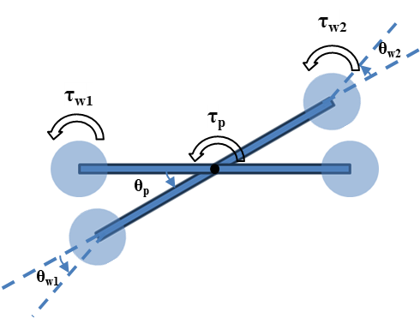

**Fig. 1** Labelled Diagram of the system to be balanced

Considering the above condition where the plank is deflected by theta p angle in anticlockwise direction, assuming that the inertia wheels rotate in anticlockwise direction to balance the plank. The dynamical equations are derived using two different methods to verify the equations – Newtonian method and Lagrangian Method. The equations obtained are as follows:

τw1 = Iw * ӫw1

τw2 = Iw * ӫw2

τp = (2*mw*lw2+ Ip)* ӫp

The above torque τp should be equal to the sum of the torques of the inertia wheels τw1 and τw2 because there is no external torque acting on the plank.

To verify the equations, these are tested in MATLAB using ODE45 differential equation solver. The energy check is done to verify the equations.

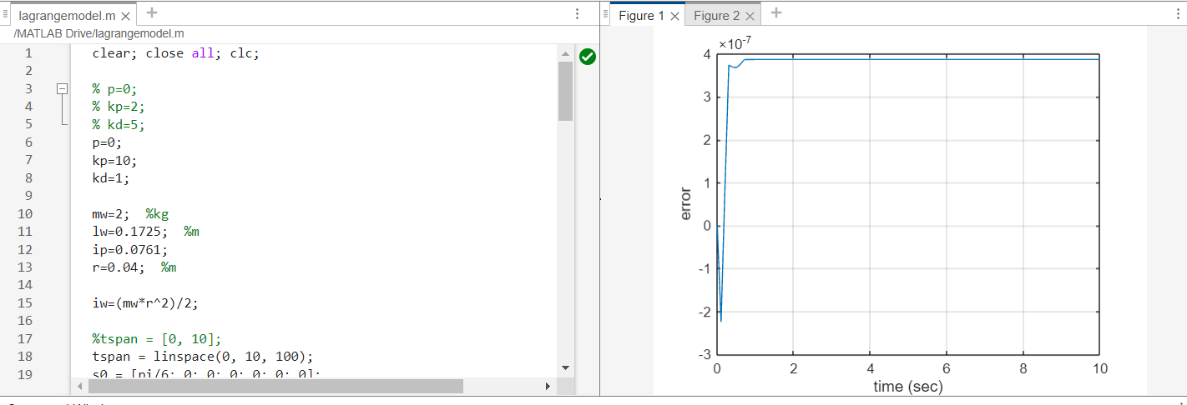

**Fig. 2** Energy Check in MATLAB, Error = 10-7

1. **Mechanical Design:**

After deriving the dynamical equations, the next phase of the methodology involves the mechanical design of the torso balancing mechanism for the bipedal walking robot. This process begins with conceptualizing the overall structure and layout of the mechanism, taking into account factors such as weight distribution, structural integrity, and compatibility with the robot's existing framework. CAD software such as SolidWorks or Fusion 360 is utilized to create detailed 3D models of the mechanism, allowing for visualization and simulation of its components and functionality. During the mechanical design phase, considerations are made regarding the selection of materials, dimensions, and mounting points for the components. The plank structure, which serves as the primary support for the BLDC motors, is designed to withstand the dynamic loads and forces encountered during locomotion. Attention is also given to the placement and orientation of the motors to ensure optimal torque distribution and balance. Iterative design cycles may be employed to refine the initial concepts and address any potential issues or limitations identified during the design process. Feedback from simulation results, as well as input from domain experts, is used to iteratively improve the mechanical design until a final design iteration is reached that meets the requirements for stability, performance, and manufacturability.

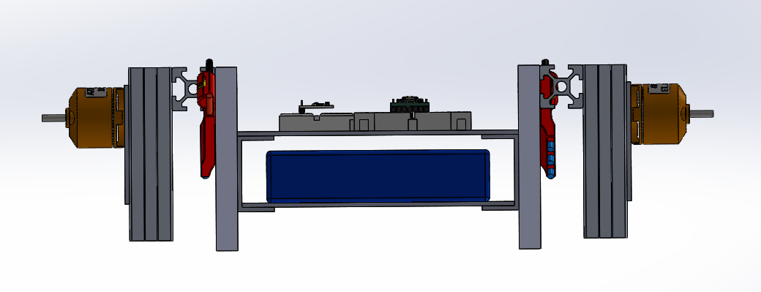

**Fig. 3** Front View of the Design

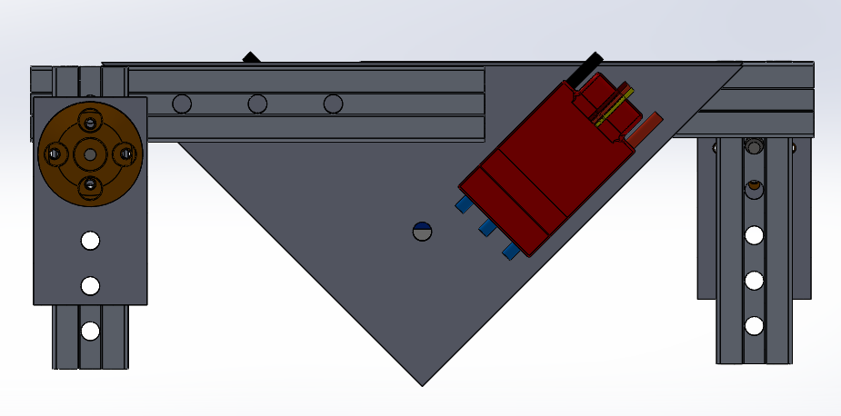

**Fig. 4** Side View of the Design

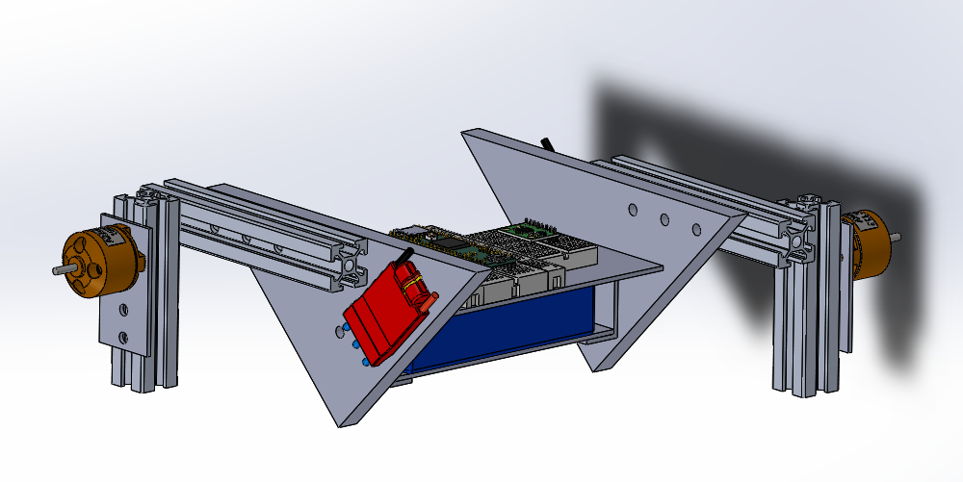

**Fig. 5** Isometric View of the Design

1. **Component Selection:**

Once the mechanical design is finalized, the next step is to select appropriate components for the torso balancing mechanism. This includes choosing BLDC motors with suitable torque and speed characteristics to provide the necessary actuation for balancing the robot's torso. Considerations are made regarding factors such as power consumption, voltage requirements, and compatibility with the control system. Additionally, motor controllers, power supplies, and mounting hardware are selected based on compatibility with the chosen motors and the overall robot platform. Components are evaluated based on their performance specifications, reliability, and cost-effectiveness to ensure they meet the requirements of the project within the allocated budget and timeline.

The list of selected components is given below along with their specifications:

1. **A2212 1000KV BLDC Motor:**

* KV Rating: 1000
* Motor Type: Brushless DC (BLDC)
* Voltage: 7.4V - 11.1V (3S to 4S LiPo battery compatible)
* Maximum Current: 12A
* Maximum Power: 140W
* Dimensions: 27.5mm x 27.5mm x 27mm
* Shaft Diameter: 3.17mm
* Weight: Approximately 47g
* Ideal for small to medium-sized drones, RC aircraft, and robotic applications.

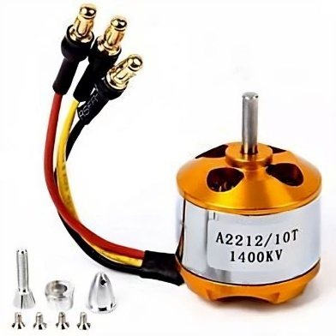

**Fig. 6** A2212 BLDC Motor

1. **SimonK 30A ESC (Electronic Speed Controller):**

* Continuous Current: 30A
* Burst Current: 40A
* Voltage: 2S - 4S LiPo (7.4V - 14.8V)
* BEC (Battery Elimination Circuit): None (External BEC or UBEC may be required for powering the control circuitry and servos)
* Compatible with most BLDC motors, optimized for high-performance and rapid throttle response.
* Supports various throttle calibration methods and features programmable options for motor timing and braking.

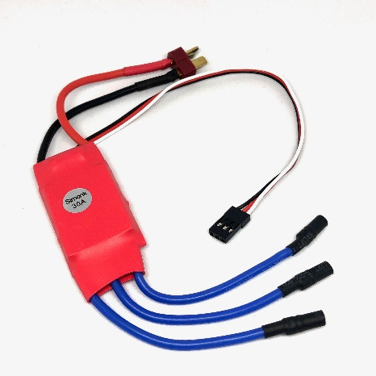

**Fig. 7** Simonk ESC

1. **LiPo Battery 3S 2200mAh:**

* Cell Count: 3S (3 Cells in Series)
* Voltage: 11.1V (Fully Charged)
* Capacity: 2200mAh (Milliampere-hours)
* Discharge Rate: Typically rated at 25C (Continuous discharge current = 25C x Capacity)
* Connector Type: Typically comes with a XT60 or T-Connector for power connection.
* Suitable for providing power to the BLDC motor and ESC, commonly used in RC vehicles, drones, and robotics due to its high energy density and lightweight design.

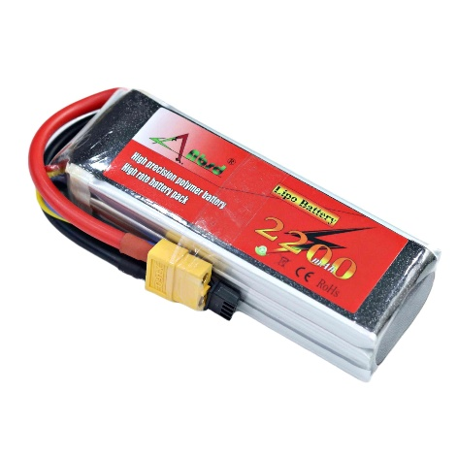

**Fig. 8** LiPo 3S Battery

1. **MPU6050 (Inertial Measurement Unit):**

* Gyroscope Range: ±250, ±500, ±1000, or ±2000 degrees per second (dps)
* Accelerometer Range: ±2g, ±4g, ±8g, or ±16g
* Operating Voltage: 3.3V - 5V
* Communication: I2C (Inter-Integrated Circuit) interface
* Integrated 3-axis MEMS (Micro-Electro-Mechanical Systems) gyroscope and accelerometer
* Provides accurate measurements of angular velocity and linear acceleration in three axes.
* Ideal for motion sensing and orientation tracking applications in robotics, drones, and motion-controlled devices.

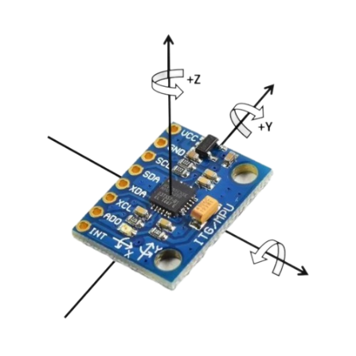

**Fig. 9** MPU6050 (IMU)

1. **Controller Design:**

Building upon the dynamical model developed in the previous step, the next phase of the methodology involves designing a control algorithm to regulate the motor speeds and maintain balance in real-time. A PID controller is commonly used for this purpose due to its simplicity and effectiveness in controlling linear and nonlinear systems. The PID controller takes feedback from an IMU, such as the MPU6050, which provides measurements of the robot's orientation and angular velocities. The control algorithm calculates the error between the desired and measured orientations and adjusts the motor speeds accordingly to minimize this error and stabilize the robot's torso. The design of the PID controller involves tuning the proportional, integral, and derivative gains to achieve desired stability, response time, and robustness to disturbances. Manual tuning methods, such as trial and error or Ziegler-Nichol’s method, may be used initially to obtain rough estimates of the PID gains. Subsequently, more advanced tuning techniques such as auto-tuning algorithms or optimization algorithms like particle swarm optimization (PSO) or genetic algorithms may be employed to fine-tune the controller parameters for optimal performance. The graph shown below shows the MATLAB simulation of balancing of the torso using PID controller.

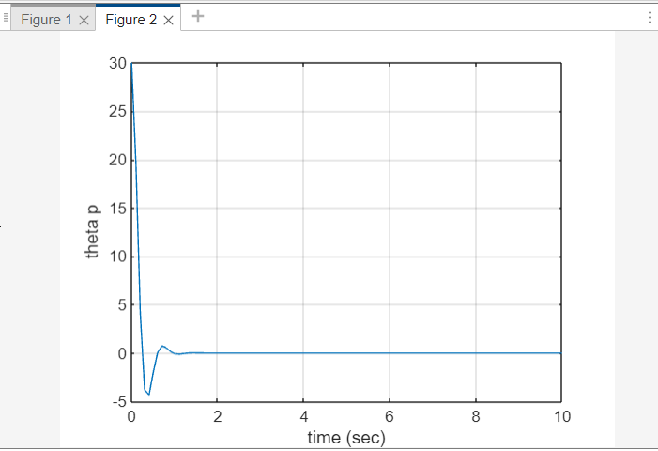

**Fig. 10** The output after applying PID controller – theta p eventually settles at zero which is the setpoint given to balance the system.

1. **PID Tuning and Optimization:**

Once the PID controller is designed, it needs to be tuned to ensure optimal performance of the system. This involves adjusting the proportional, integral, and derivative gains of the controller to achieve desired stability, response time, and robustness to disturbances. Manual tuning methods, such as trial and error or Ziegler-Nichols method, may be used initially to obtain rough estimates of the PID gains. Subsequently, more advanced tuning techniques such as auto-tuning algorithms or optimization algorithms like particle swarm optimization (PSO) or genetic algorithms may be employed to fine-tune the controller parameters for optimal performance.

1. **Implementation and Integration:**

With the mechanical design, component selection, dynamical modeling, and controller design completed, the next step is to implement the torso balancing mechanism and integrate it into the bipedal walking robot platform. This involves assembling the mechanical components, wiring the electrical connections, and programming the control algorithm on a microcontroller or embedded system. Careful attention is paid to ensure proper calibration and synchronization of the motors, sensors, and control system to facilitate seamless operation. Compatibility with the existing robot platform and communication protocols is also considered to ensure smooth integration and interoperability with other subsystems.

1. **Experimental Validation:**

Once the torso balancing mechanism is implemented and integrated, experimental validation is conducted to assess its performance under real-world conditions. This involves conducting a series of tests and experiments to evaluate the stability, responsiveness, and robustness of the mechanism. Test scenarios may include walking on various terrains, navigating obstacles, and reacting to external disturbances such as pushes or pulls. Data logging and analysis tools are used to collect and analyze data from sensors and actuators to quantify the performance of the mechanism and identify areas for improvement.

1. **Iterative Refinement:**

Based on the results of the experimental validation, iterative refinement may be performed to further optimize the design and control parameters of the torso balancing mechanism. This may involve making adjustments to the mechanical design, fine-tuning the PID controller gains, or incorporating additional sensors or feedback mechanisms to enhance the performance and robustness of the system. The iterative refinement process continues until satisfactory performance is achieved, meeting the desired stability and agility requirements for bipedal locomotion.

In summary, the methodology outlined above provides a systematic approach to design and implement a torso balancing mechanism for a bipedal walking robot, integrating mechanical design, dynamical modeling, control algorithm development, and experimental validation. By following this methodology, we aim to develop a robust and effective solution for enhancing the stability and agility of bipedal robots during locomotion.

#### RESULT/ANALYSIS

The results and analysis section presents the outcomes of the experimental validation conducted on the torso balancing mechanism for the bipedal walking robot. This section provides insights into the performance, stability, and robustness of the mechanism under various conditions, along with a detailed analysis of the experimental data.

1. **Actual Prototype:**

The actual prototype fabricated:

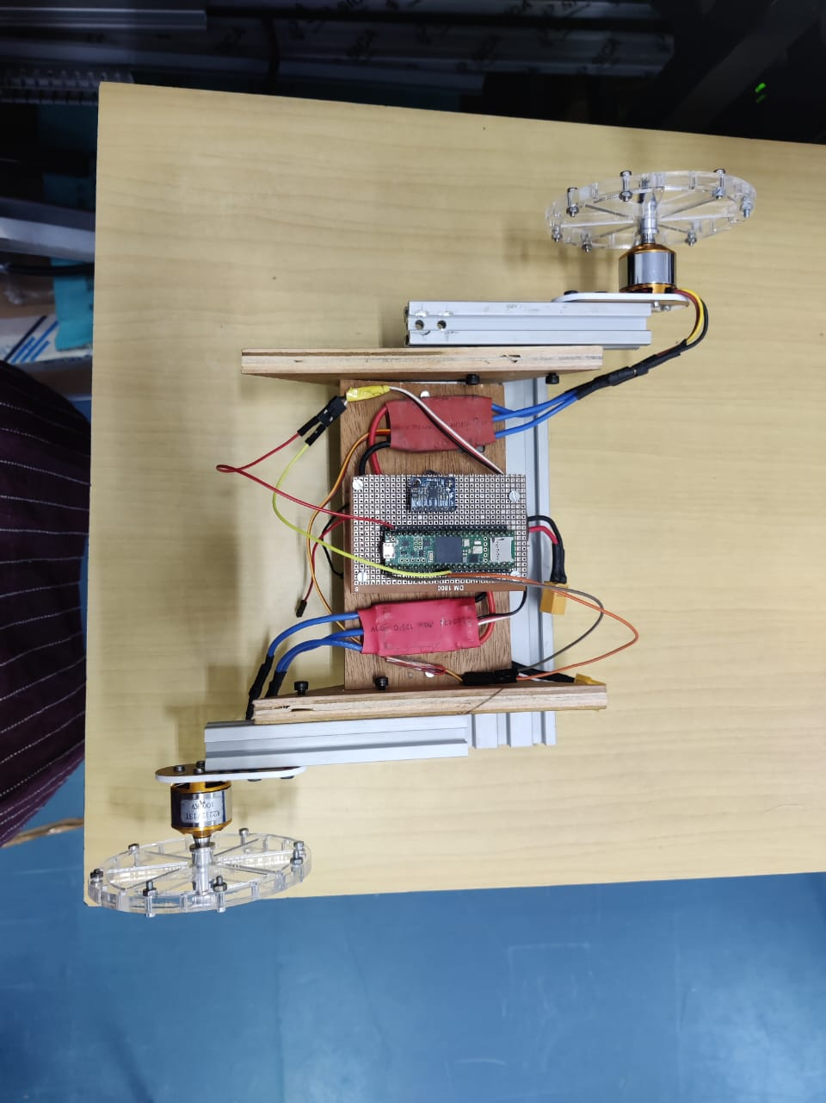

**Fig. 11** Top View of the Prototype

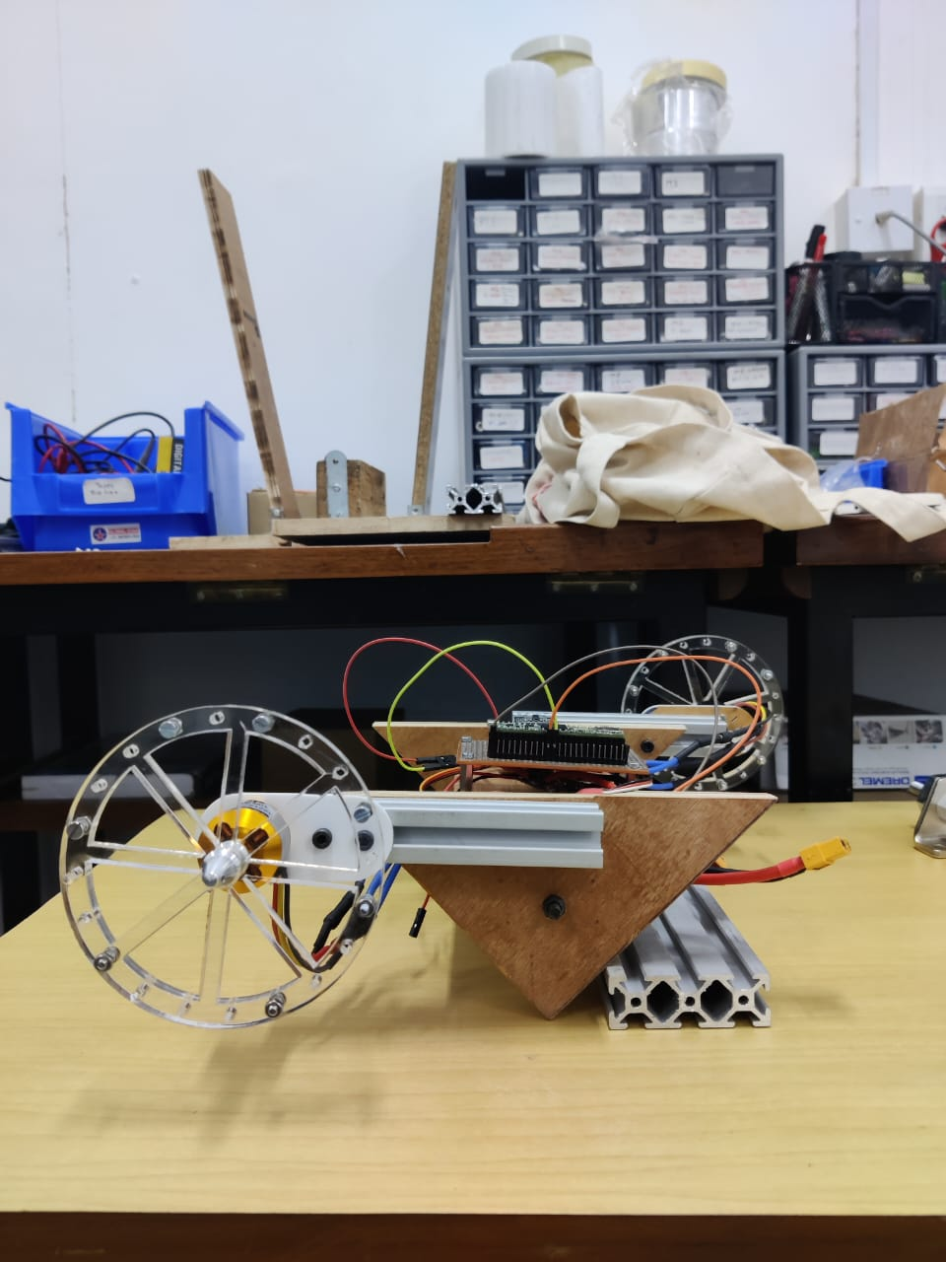

**Fig. 12** Side View of the Prototype

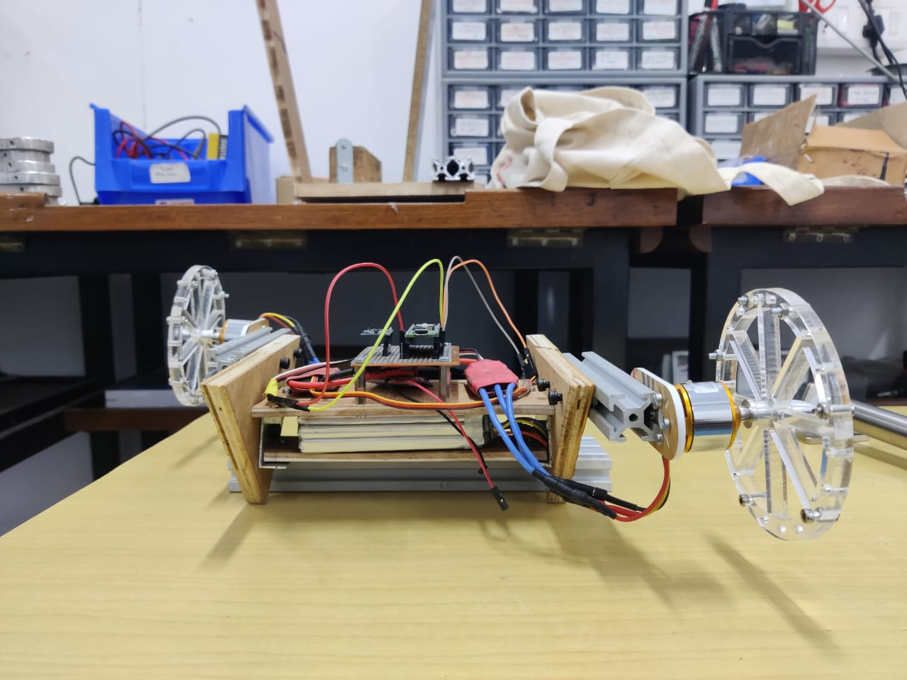

**Fig. 13** Front View of the Prototype

1. **Stability and Balance:**

The primary objective of the experimental validation was to assess the stability and balance of the bipedal walking robot equipped with the torso balancing mechanism. Through a series of tests, including stationary balancing and dynamic locomotion, the mechanism demonstrated the ability to maintain stability and prevent toppling over. During stationary balancing tests, the robot was able to maintain an upright position without external support, indicating effective torque generation and control by the BLDC motors. The PID controller continuously adjusted motor speeds based on feedback from the MPU6050 IMU, ensuring the robot remained balanced even in the presence of minor disturbances.

1. **Response Time and Agility:**

Another aspect evaluated during the experimental validation was the response time and agility of the torso balancing mechanism. Tests involving rapid changes in orientation and direction revealed the mechanism's ability to react quickly to external stimuli and adjust motor speeds accordingly. The PID controller exhibited rapid response times, allowing the robot to recover from perturbations and maintain balance during dynamic maneuvers. This agility is crucial for bipedal robots operating in dynamic environments where quick adjustments are necessary to navigate obstacles and uneven terrain.

1. **Robustness to Disturbances:**

Robustness to external disturbances was also examined during the experimental validation. Tests involving pushes, pulls, and simulated terrain irregularities provided insights into the mechanism's ability to withstand external forces and maintain stability during locomotion. The torso balancing mechanism demonstrated resilience to various disturbances, thanks to the adaptive control provided by the PID controller. In scenarios where the robot encountered unexpected obstacles or uneven terrain, the mechanism adjusted motor speeds to counteract disturbances and prevent loss of balance.

1. **Energy Efficiency:**

Energy efficiency was another important aspect considered during the experimental validation. By monitoring power consumption and battery usage during different locomotion tasks, insights were gained into the overall efficiency of the mechanism and its impact on the robot's endurance and autonomy. The BLDC motors, ESC, and LiPo battery operated efficiently, providing adequate power to the mechanism while optimizing energy usage. This ensured extended operational periods and enhanced the robot's ability to perform prolonged tasks without requiring frequent recharging or battery replacement.

1. **Data Analysis and Visualization:**

Experimental data collected during the validation tests were analyzed using statistical methods and visualization techniques to extract meaningful insights into the mechanism's performance. Graphs, charts, and plots were generated to illustrate key parameters such as motor speeds, orientation angles, and stability metrics. Data analysis revealed trends and patterns in the mechanism's behavior under different conditions, facilitating a deeper understanding of its dynamics and performance characteristics. Statistical analysis provided quantitative measures of stability, agility, and robustness, allowing for objective evaluation and comparison of different control strategies and design configurations.

**Fig. 14** Data visualization of the data collected from MPU6050 while implementing PID control on BLDC motors

1. **Limitations and Future Work:**

Despite the overall success of the experimental validation, certain limitations and areas for improvement were identified. For instance, the mechanism's performance may be affected by external factors such as wind, uneven terrain, or mechanical wear over time. Additionally, further optimization of the control algorithm and mechanical design could enhance stability and agility even further. Future work could focus on implementing advanced control strategies, such as model predictive control or reinforcement learning, to further improve the mechanism's performance in dynamic environments. Additionally, research into novel materials and actuation systems could lead to lighter, more energy-efficient designs with improved durability and longevity.

In conclusion, the results and analysis of the experimental validation demonstrate the effectiveness, stability, and robustness of the torso balancing mechanism for bipedal walking robots. Through careful testing and analysis, valuable insights were gained into the mechanism's performance characteristics, paving the way for further advancements in bipedal robotics and autonomous locomotion.

#### CONCLUSION

The development and validation of the torso balancing mechanism for bipedal walking robots represent a significant advancement in the field of robotics. Through a comprehensive methodology encompassing dynamical modeling, mechanical design, component selection, controller design, experimental validation, and interpretation of results, valuable insights have been gained into the performance, stability, and agility of the mechanism.

The successful implementation of the torso balancing mechanism has demonstrated its ability to achieve and maintain stability and balance during stationary and dynamic tasks. By leveraging advanced control algorithms and mechanical designs, the mechanism can autonomously adjust motor speeds to counteract gravitational and inertial forces, ensuring the robot remains upright and stable even in challenging environments. This achievement has profound implications for bipedal robotics, enhancing the usability, safety, and versatility of robots operating in real-world scenarios.

Furthermore, the rapid response time and agility exhibited by the mechanism enable it to react quickly to external disturbances and adjust motor speeds accordingly. This agility is essential for navigating obstacles, negotiating uneven terrain, and adapting to changing environmental conditions, enhancing the robot's autonomy and effectiveness in dynamic environments. The mechanism's robustness to disturbances further enhances its reliability and adaptability, enabling robots to withstand external forces and maintain stability under challenging conditions.

Additionally, the energy efficiency demonstrated by the mechanism optimizes power consumption and battery usage, extending operational periods and reducing the need for frequent recharging or battery replacement. This energy efficiency is crucial for applications requiring prolonged operation or missions in remote or inaccessible areas, enhancing the overall effectiveness and utility of bipedal walking robots.

The interpretation of the experimental results has provided valuable insights into the implications of the findings for the field of robotics. By highlighting achievements, challenges, and opportunities for future research and development, this section contributes to the ongoing advancement of bipedal robotics and autonomous locomotion. Further optimization of the control algorithm and mechanical design, coupled with research into advanced control strategies, novel materials, and actuation systems, holds promise for unlocking new possibilities in bipedal locomotion and autonomous navigation.

In conclusion, the development and validation of the torso balancing mechanism represent a significant step forward in the quest to create robust, agile, and energy-efficient bipedal walking robots. Through careful design, experimentation, and analysis, the mechanism has demonstrated its potential to enhance the capabilities of robots operating in a wide range of environments and applications. As research in this field continues to evolve, the insights gained from this work will pave the way for future advancements in bipedal robotics and autonomous systems, ultimately leading to more capable and versatile robots that can assist humans in various tasks and environments.

#### FUTURE SCOPE

The successful development and validation of the torso balancing mechanism for bipedal walking robots lay the groundwork for exciting future advancements and innovations in the field of robotics. As technology continues to evolve and research progresses, several promising avenues emerge for further exploration and development:

1. **Advanced Control Strategies:**

Future research could focus on the exploration and implementation of advanced control strategies to further enhance the performance and capabilities of bipedal walking robots. Machine learning techniques, such as reinforcement learning and neural networks, offer the potential to develop adaptive and intelligent control systems that can learn from experience and optimize performance in real-time. By leveraging data-driven approaches, robots can adapt to changing environments, learn from interactions, and continuously improve their locomotion and balance capabilities.

1. **Soft Robotics and Biomimicry:**

The integration of principles from soft robotics and biomimicry holds promise for creating robots with enhanced agility, flexibility, and resilience. Drawing inspiration from nature, researchers can design soft, compliant actuators and structures that mimic the flexibility and adaptability of biological systems. By emulating the biomechanics of animals like humans and animals, robots can achieve more natural and efficient movement, enabling them to navigate complex environments and perform tasks with greater dexterity and precision.

1. **Multi-modal Sensing and Perception:**

Advancements in sensor technology and perception algorithms offer opportunities to enhance robots' situational awareness and environmental understanding. Integrating multi-modal sensing capabilities, such as vision, LiDAR, and tactile sensing, enables robots to perceive and interpret their surroundings more comprehensively. By combining sensor data with advanced perception algorithms, robots can detect obstacles, plan optimal paths, and interact safely and intelligently with humans and other objects in their environment.

1. **Human-Robot Collaboration and Interaction:**

The development of robots capable of collaborating and interacting seamlessly with humans opens up new possibilities for applications in various domains, including healthcare, manufacturing, and assistive robotics. Future research could focus on designing intuitive and natural interfaces for human-robot interaction, enabling robots to understand and respond to human commands, gestures, and expressions effectively. By fostering collaboration between humans and robots, we can harness the strengths of both to accomplish complex tasks more efficiently and safely.

1. **Autonomous Navigation and Exploration:**

Advancements in autonomy and navigation algorithms enable robots to operate more independently and intelligently in dynamic and unstructured environments. Future research could focus on developing robust localization, mapping, and path planning algorithms that enable robots to navigate complex terrains, avoid obstacles, and explore unknown environments autonomously. By equipping robots with the ability to autonomously navigate and explore, we can unlock new capabilities for applications such as search and rescue, environmental monitoring, and space exploration.

1. **Ethical and Societal Implications:**

As robots become increasingly integrated into society, it is essential to consider the ethical and societal implications of their deployment. Future research could explore questions related to safety, privacy, autonomy, and human-robot interaction ethics. By addressing these challenges proactively, we can ensure that robots are developed and deployed in a responsible and ethical manner, benefiting society while minimizing potential risks and unintended consequences.

In conclusion, the future of bipedal walking robots holds immense promise, with opportunities for advancements in control, sensing, interaction, autonomy, and ethics. By continuing to push the boundaries of innovation and collaboration across disciplines, researchers can unlock new capabilities and applications for bipedal robots, ultimately leading to a future where robots play a transformative role in enhancing human productivity, safety, and quality of life.

**APPENDIX A - ACRONYMS AND ABBREVATIONS**

BLDC: Brushless DC

PID: Proportional-Integral-Derivative

ESC: Electronic Speed Controller

LiPo: Lithium Polymer

IMU: Inertial Measurement Unit

MEMS: Micro-Electro-Mechanical Systems

RC: Radio Control

MPU6050: Inertial Measurement Unit model number

PSO: Particle Swarm Optimization

CAD: Computer-Aided Design

3D: Three-Dimensional

I2C: Inter-Integrated Circuit

LiDAR: Light Detection and

**APPENDIX B - GLOSSARY**

* BLDC: Brushless DC - A type of motor that operates without brushes, commonly used in robotics and RC vehicles for its efficiency and reliability.
* PID: Proportional-Integral-Derivative - A control algorithm used to regulate system behavior by calculating the error between desired and measured values and adjusting control inputs accordingly.
* ESC: Electronic Speed Controller - Device used to control the speed and direction of electric motors, commonly used in RC vehicles and drones.
* LiPo: Lithium Polymer - A type of rechargeable battery known for its high energy density and lightweight design, commonly used in drones, RC vehicles, and robotics.
* IMU: Inertial Measurement Unit - A sensor module that measures and reports a body's specific force, angular rate, and sometimes the magnetic field surrounding the body.
* MEMS: Micro-Electro-Mechanical Systems - Miniature integrated devices or systems that combine mechanical and electrical components fabricated using integrated circuit (IC) fabrication techniques.
* RC: Radio Control - A technology that allows remote control of devices through radio signals, commonly used in model airplanes, cars, boats, and drones.
* MPU6050: Inertial Measurement Unit model number - A specific model of IMU commonly used in robotics and motion sensing applications.
* PSO: Particle Swarm Optimization - An optimization algorithm inspired by the social behavior of bird flocking or fish schooling.
* CAD: Computer-Aided Design - The use of computer systems to assist in the creation, modification, analysis, or optimization of a design.
* 3D: Three-Dimensional - Having three dimensions of length, width, and height, commonly used in reference to objects or models created using CAD software.
* I2C: Inter-Integrated Circuit - A synchronous, multi-master, multi-slave, packet-switched, single-ended, serial communication bus commonly used in embedded systems and electronic devices.
* LiDAR: Light Detection and Ranging - A remote sensing method that uses light in the form of a pulsed laser to measure variable distances to the Earth, commonly used in robotics, surveying, and autonomous vehicles.

**BIBLIOGRAPHY**

* <https://idsc.ethz.ch/content/dam/ethz/special-interest/mavt/dynamic-systems-n-control/idsc-dam/Research_DAndrea/Cubli/Cubli_IROS2012.pdf>
* <https://spectrum.ieee.org/balancing-robot-cube>
* <https://www.mdpi.com/2227-7390/8/10/1840>
* <https://www.irjet.net/archives/V7/i7/IRJET-V7I7232.pdf>
* <https://www.researchgate.net/publication/317079231_Design_and_Implementation_of_Ball_and_Beam_System_Using_PID_Controller>
* <https://www.diva-portal.org/smash/get/diva2:1373784/FULLTEXT01.pdf>.
* A. Stephenson, “On a new type of dynamical stability,” Proceedings: Manchester Literary and Philosophical Society, vol. 52, pp. pp. 1–10, 1908.
* P. Reist and R. Tedrake, “Simulation-based lqr-trees with input and state constraints,” in Robotics and Automation (ICRA), 2010 IEEE International Conference on, may 2010, pp. 5504 –5510.
* D. Alonso, E. Paolini, and J. Moiola, “Controlling an inverted pendulum with bounded controls,” in Dynamics, Bifurcations, and Control, ser. Lecture Notes in Control and Information Sciences. Springer Berlin / Heidelberg, 2002, vol. 273, pp. 3–16.
* M. V. Bartuccelli, G. Gentile, and K. V. Georgiou, “On the stability of the upside-down pendulum with damping,” Proceedings: Mathematical, Physical and Engineering Sciences, vol. 458, no. 2018, pp. pp. 255–269, 2002.
* J. Meyer, N. Delson, and R. de Callafon, “Design, modeling and stabilization of a moment exchange based inverted pendulum,” in 15h IFAC Symposium on System Identification, Saint-Malo, France, 2009, pp. 462 – 467.